***Project Proposal***

***Members Names***:

Noman Siddique (19P-1664) & Ibrar Babar(19P-0104)

***Project Name:***

**College Admission Predictor**

***Description:***

This project Engineering Admission Predictor System is web based application in which students can register with their personal as well as marks details for prediction the admission in colleges and the administrator can allot the seats for the students. Administrator can add the college details and he batch details. Using this software, the entrance seat allotment became easier and can be implemented using system. The main advantage of the project is the computerization of the entrance seat allotment process. Administrator has the power for the allotment. He can add the allotted seats into a file and the details are saved into the system. The total time for the entrance allotment became lesser and the allotment process became faster.

***Advantages:***

* It helps student for making decision for choosing a right college.
* Here the chance of occurrence of error is less when compared with the existing system.
* It is fast, efficient and reliable.
* Avoids data redundancy and inconsistency.
* Very user-friendly.
* Easy accessibility of data.

***Used Language and Styles:***

* Html
* Css
* JavaScript.
* JQuery.
* PHP.
* MySQL.

***Preview:***

***Main Page***



***About US.php***



***Our Vision.php***



***Services.php***



***Login.php***

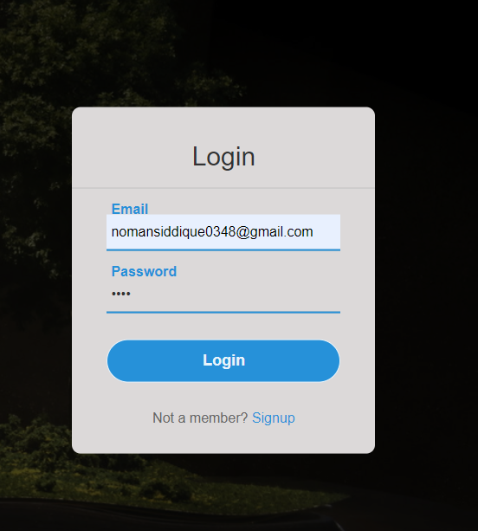

***Register.php***

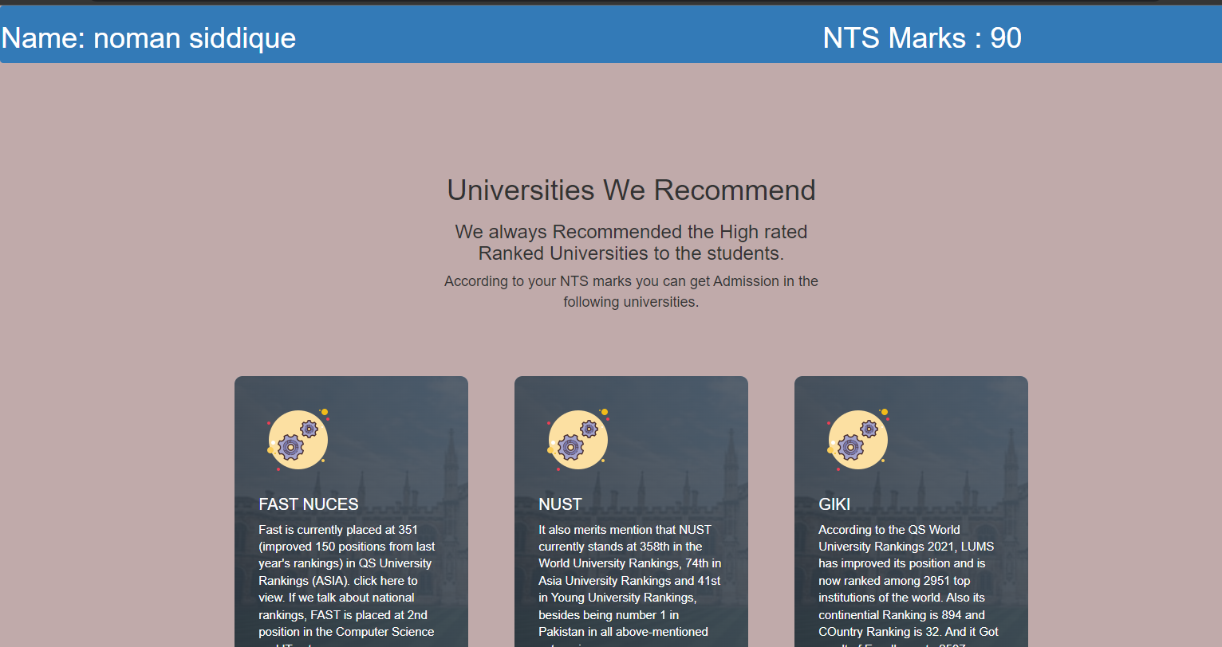

***Database:***

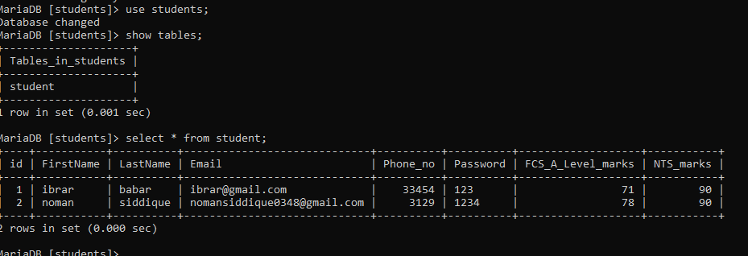

***Project Code:***

